GeoPIXE Recent News

Version 9.0

New versions of files
A few files have new information added (images: .DAI, DA matrix: .DAMX). These cannot be read using older versions of GeoPIXE. This is largely why we have a fresh break to version 9.0 of GeoPIXE. However, the new version of GeoPIXE can still read all previous version files.

Energy cal file name
When an energy cal file is selected, using the “Get” button on the “DA/E.Cal” tab of Sort EVT, the filename gets saved in the returned image and the new DAI file (now version -58). The energy cal filename can be seen in the Image History details and in the preview text in the File Requester (see the “Details” tab).

Fitted spectrum file name
The file name for the spectrum fitted to generate a DA matrix is now saved with the DA matrix (DA matrix file, e.g. “.damx”, are now version -10). This enables re-fitting this spectrum later to refine some aspects of the fit (e.g. add an element) and generate a new DA matrix. The spec filename can be seen in the preview text in the File Requester (see the “Details” tab) when selecting DA matrix files. The preview also shows the beam energy.

Refit source spectrum to regenerate a new DA matrix
A new menu “Load DA spectrum for refit” under “Process” on the main Image window can be used to reload the source spectrum used in the fit to generate the DA matrix originally. This will also load the PCM file (assumes same name as DA matrix file). Once loaded, you can refine fit parameters (e.g. add a missing element), refit the spectrum and generate a new DA matrix for refined processing.

This feature makes use of the spec_file saved in new DA matrix files. If not present (older DA file), a file requester will pop up for you to select the source spec file.

Probing hotspots in images
A new “Hotspots” menu on the Image Regions table provides tools for separating individual hotpots (and their neighbourhood pixels) in images and probing these and extracting spectra from them individually. See worked example C6 for some details.

Version 8.9t

Cluster mode logging optional
Previously, background processes launched in “Cluster” parallel processing mode would generate a log file each (saved to your home .geopixe/ directory). These need to be deleted from time to time en masse. This is now optional and disabled by default. To enable logging (if parallel processing appears to be failing) add a line “cluster log 1” to your ‘geopixe.conf’ file in your home .geopixe directory.

Version 8.9s

GUI Layout on hires screens
All windows now adapt to changes in default system font affecting text in widget programs. Hence, system scaling or changes to selected font sizes should display correctly.

Version 8.9r

Apple Silicon MAC Support
All low-level Fortran libraries (now v57) have been compiled for Apple Silicon devices, such as the M1, M2, M3, M4 and M5 processors using ARM processors. They also support x86 64 bit Apple systems as well as 64 bit and 32 bit Linux x86 systems and Windows x86 systems. There is no support for 32 bit Apple systems.

Display issues remain on stock MAC systems, which require an upgrade of the XQuartx display system. Even this does not solve many MAC issues. We have sought help from NV5, the developers of IDL.

Version 8.9n

FalconX (Merge) device
Fixed extraction of spectra to correctly process the filenames, which include “_nn” for detector number in an array as well as the trailing “_n” for sequence number of the list mode data sequence. This fixes potential loss of data into extracted spectra, which may also affect the Standards Wizard processing.

Black periodic table “elements” under Linux
A strange behaviour under Linux leads to some element tiles in periodic tables of elements (Identify and Xray spectrum fit windows) going black after some hours, like the system’s “expose” updates get lazy and stop arriving. A fix forces these to be done, which should fix this Linux only behaviour.

Version 8.9j

Zoom and Pan on Image
Use Control-Left mouse to move the image. Control-Left click on a feature and drag to where you’d like that feature to be moved to. Nothing is drawn. On release the image is moved. For example, control-left click and hold on a feature and drag it and release at the centre of the window.

Use Control-Scroll wheel to increment the Zoom level in and out. The display zooms around the current centre.

Refine pixel selections for a selective Traverse
If you would like to look at the variation of a particular element constrained to just a certain mineral phase, for example, ignoring other phases along a Traverse line, then this is for you.

Look at the worked example dataset (file “Demo/CSIRO/c4-x/c4-x-3-b.dai”), which has a solid-solution series in Fe versus Cu sulphides varying from near pyrite (FeS₂) through to near pure villamaninite (CuS₂), as well as some enargite (Cu₃AsS₄).

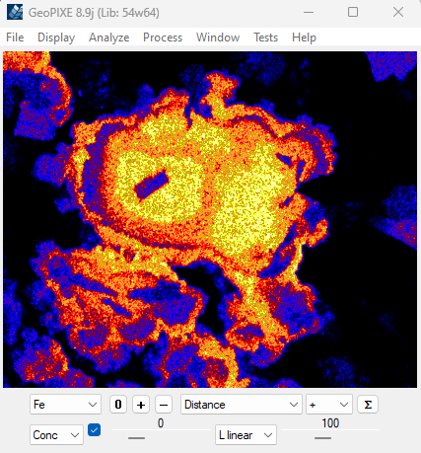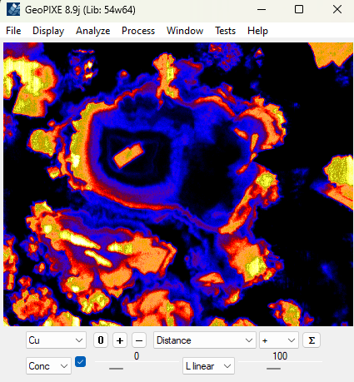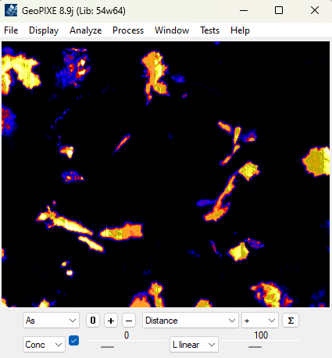

We want to look at the variation of Cu and Fe across the solid-solution members and ignore the enargite. A normal traverse looks like this …

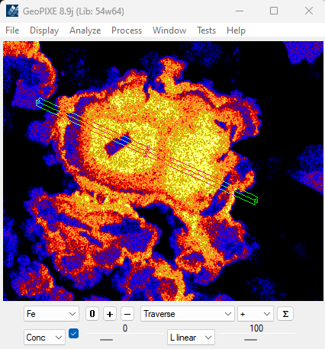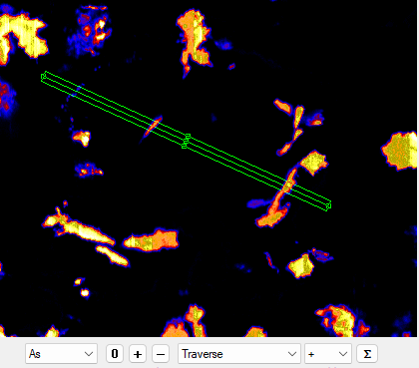
which includes some high-Cu,As enargite regions …
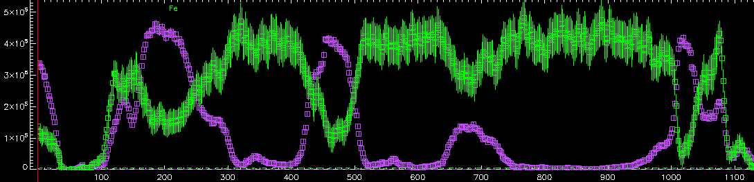
Fe (green), Cu (violet)

Constraining our pixels to exclude the enargite, using an Association window plot of Cu versus As, we can avoid the enargite areas …

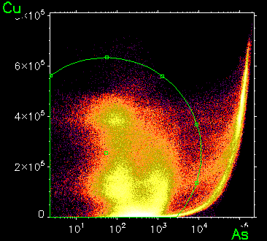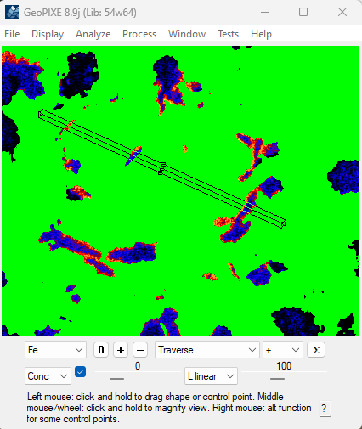

Now you can show a Traverse that skips those regions by using the new Image window menu “Analyze->Further refine highlighted pixels within spline”, which just refines the green Association selected pixels constrained within the Traverse rectangle …

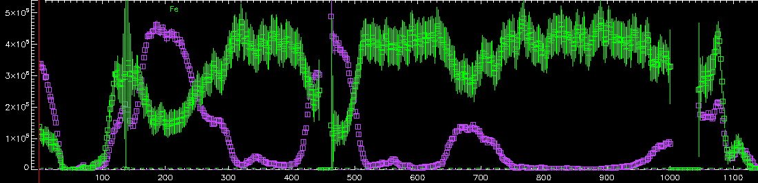
Fe (green), Cu (violet)

Version 8.9g

New Help windows
The “Help” menus on the Image and Spectrum Display windows have been updated to open embedded browser windows showing aspects of the GeoPIXE documentation, such as GeoPIXE Overview, the GeoPIXE Manual, Maia detector notes and the GeoPIXE Worked Examples and including the open source GeoPIXE GitHub link and links to the Worked Examples data on CSIRO DAP.

Window specific help
Small “?” buttons in the bottom-right corner of most windows will launch the new help browser for the GeoPIXE Users Guide and jump to the section for that window.

Version 8.9e

Magnify Zoom in the Image window
Holding down the Middle Mouse button (or zoom scroll wheel) will show a magnified view of the pixels near the cursor in the Image window. The zoom will always show magnified pixels regardless of the current ‘zoom’ level. Click, hold and drag to move the “magnifier” across the image.

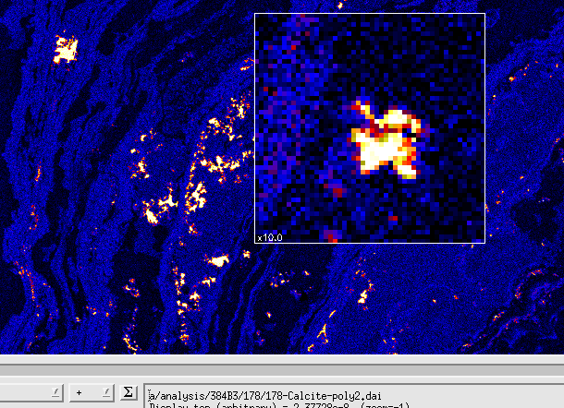

Version 8.9d

Detector Map
A new Detector Map window (see “Detector Map” on the “Windows” menu on the Spectrum Display window) can be used to show the count-rate (or element concentrations) variation across the Maia detector array (or any array detector). It processes spectral loaded into Spectrum Display for individual detector channels. You can load and select a DA matrix file, which is used to transform these spectra into element signals, detector by detector, using a selected array detector layout spec. The model variation in Relative Sensitivity across the array (rGamma) can be normalized out with the “rGamma norm” option.

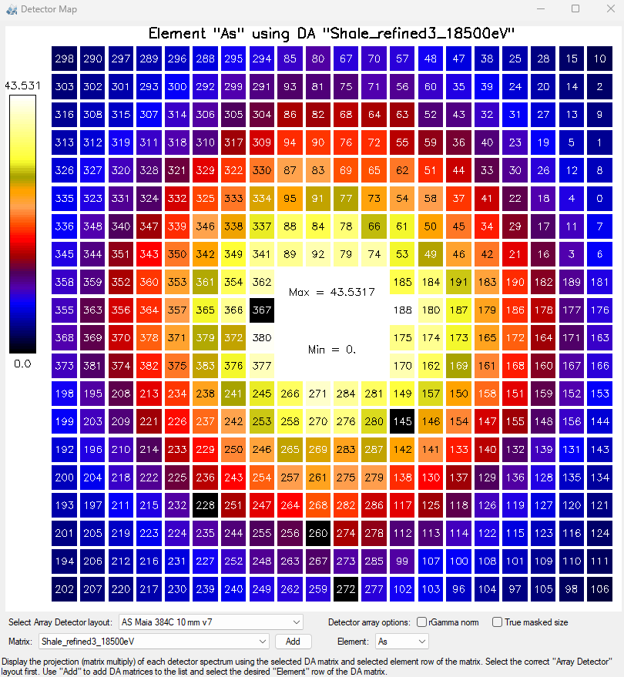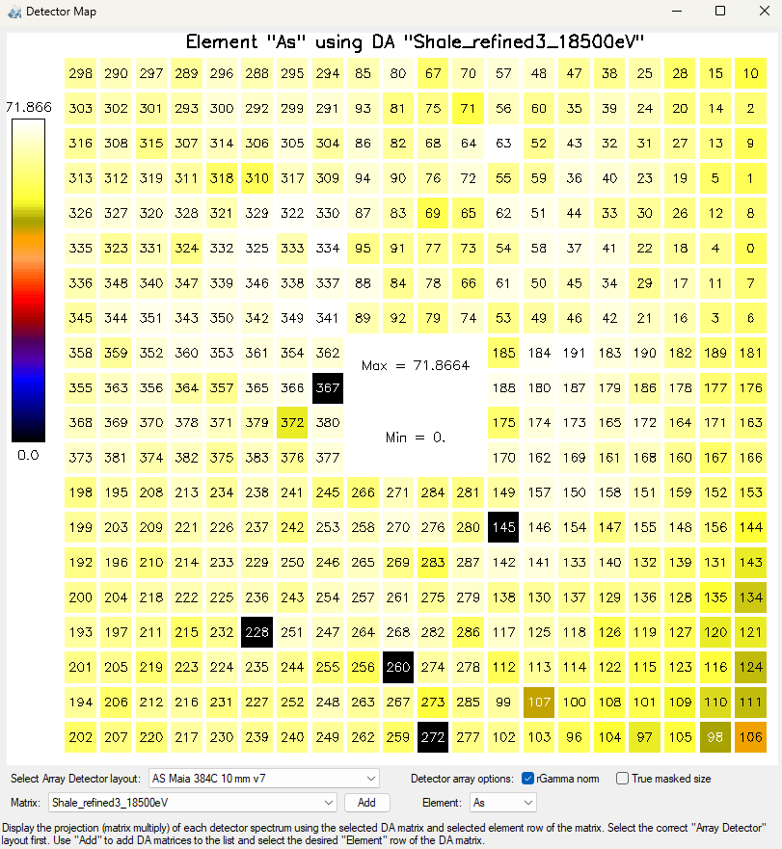

Colour Maps
Added colour tables for the “Inferno” and “Viridis” colour maps.

X,Y Histograms in Association
Added X and Y projection histograms to the Association window. Access using the tabs on the right side.

Batch Wizard
A new Wizard has been added as a more extendable replacement to Batch Sort.

